Experiment Number : 5

Problem Statement: Design and deploy a web application in a PaaS environment.
NAME:Bhagyesh Sujitkumar Gaikwad ROLLNO: 81
CLASS: IT-B BATCH: B3
DATE OF PERFORMANCE: 27-03-2025

Steps:
- Logging to Weather System.

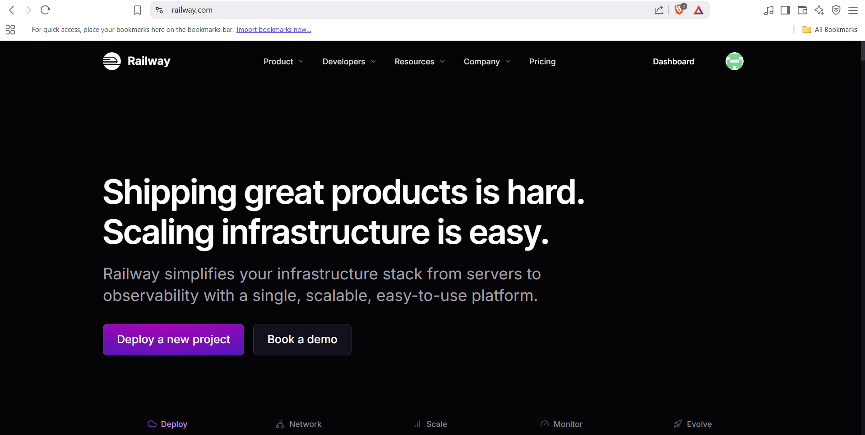

- Authorizing Railway.com with Github for deployment

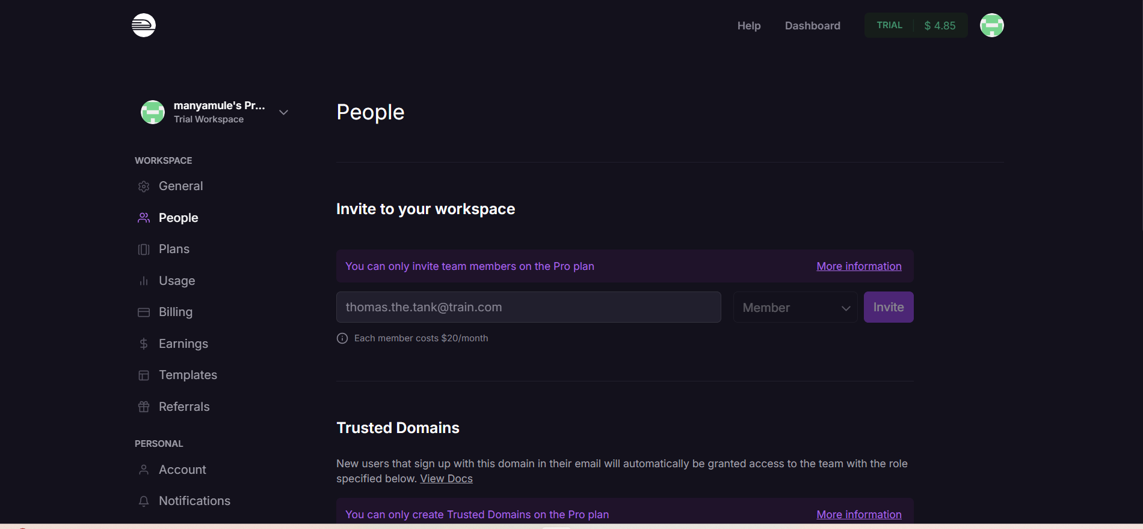

- Configuring App Settings

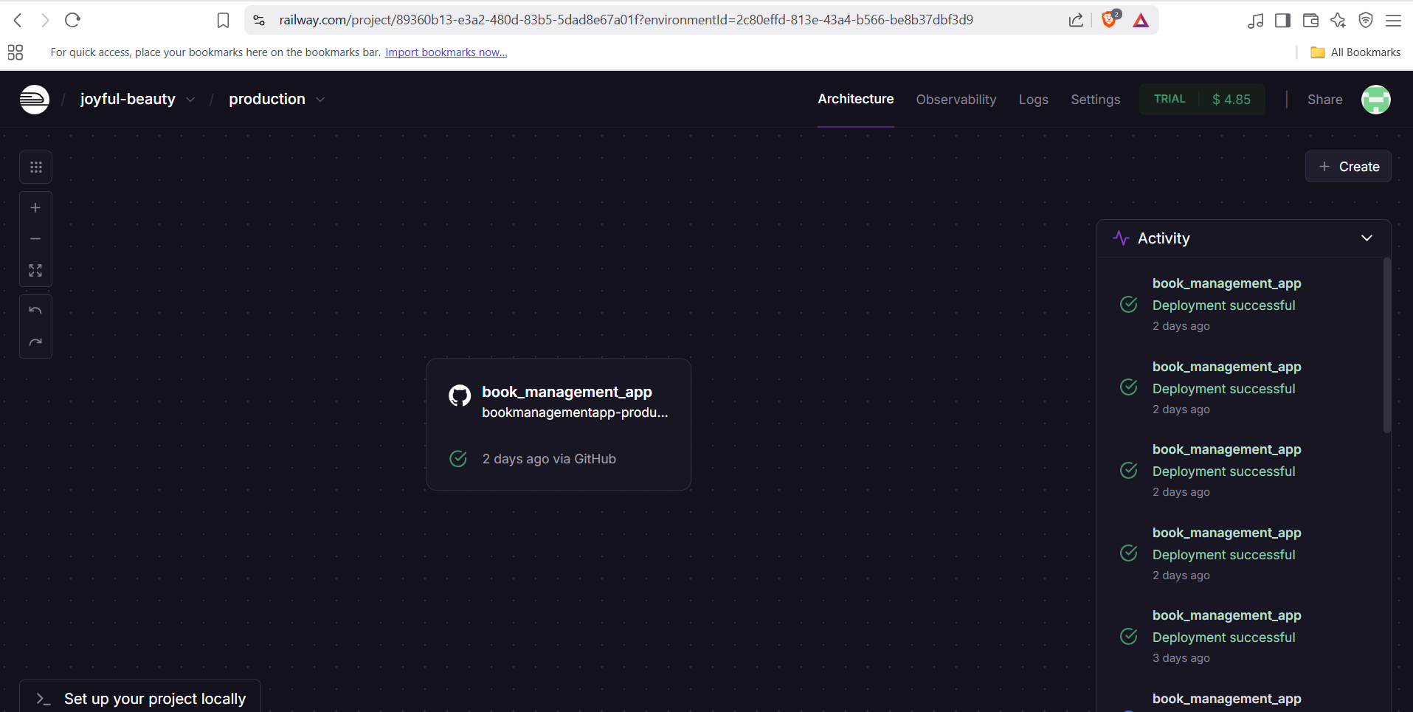

- Successful Deployment over Railway:
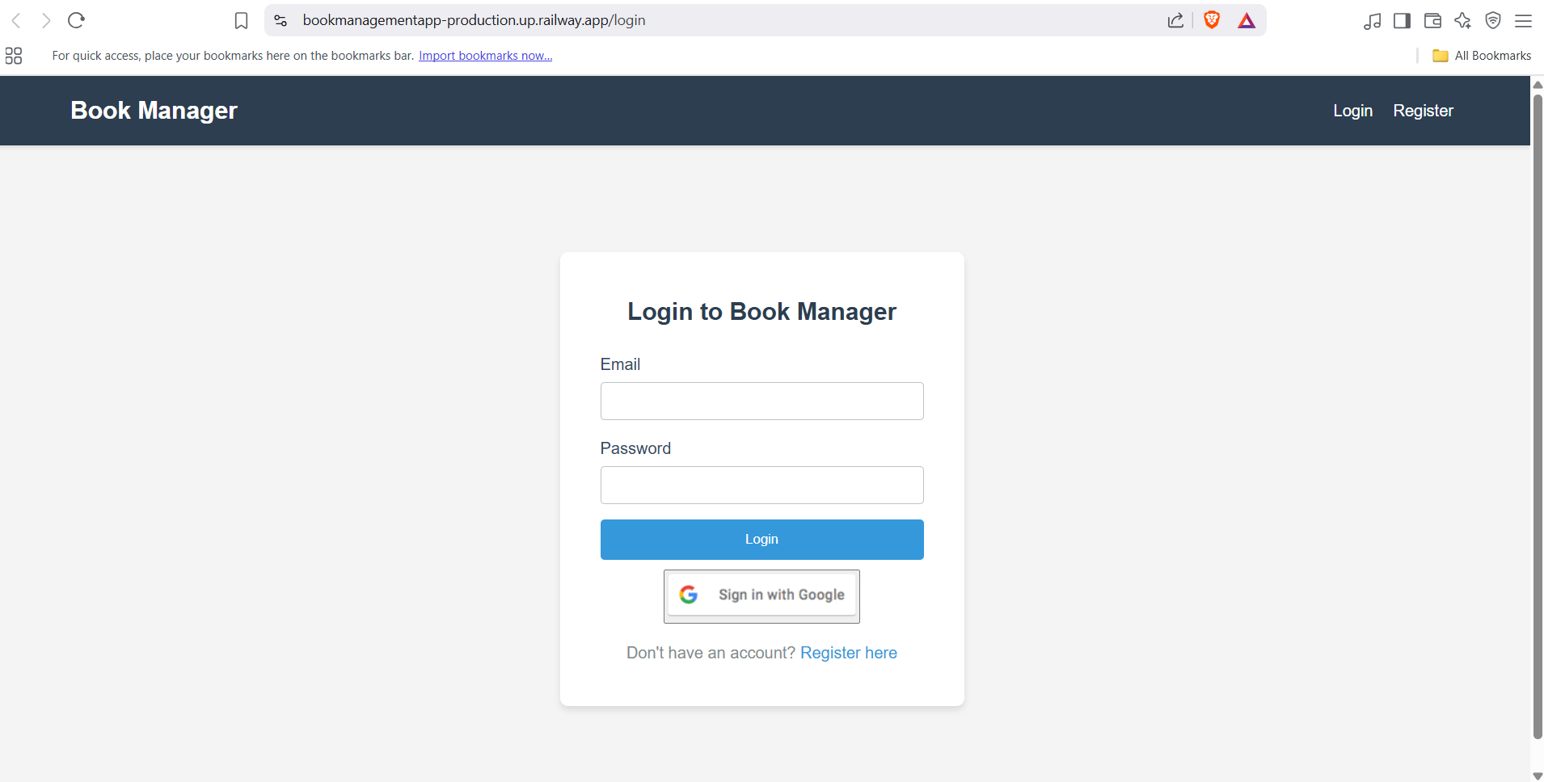

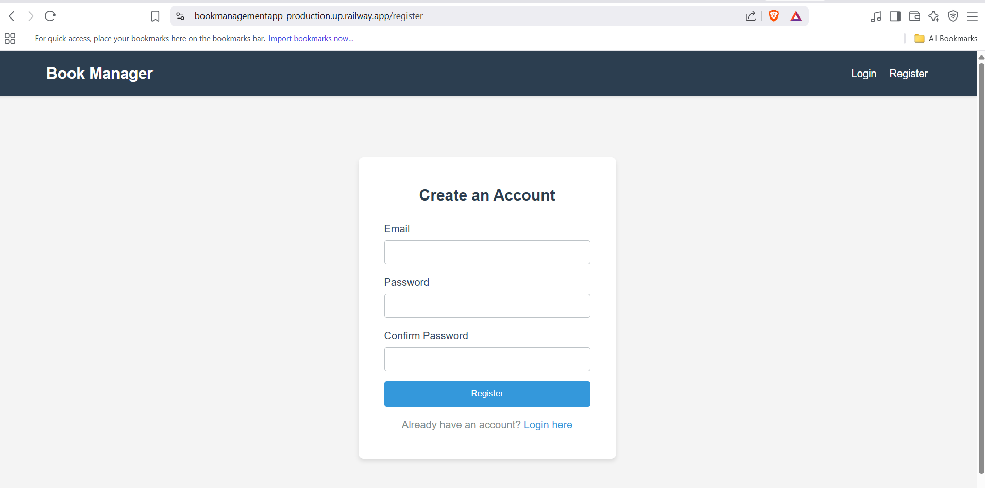
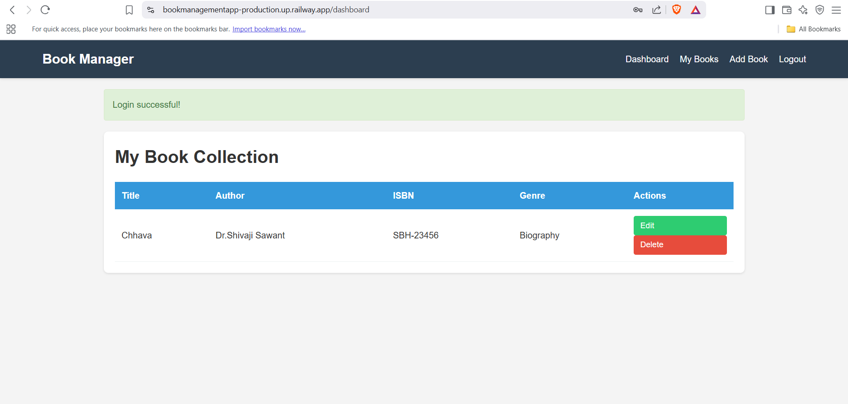

Conclusion:
In this problem statement, we successfully designed and deployed a web application in a
PaaS environment using Railway.app. By following the streamlined steps,
we efficiently hosted the application, demonstrating the ease of integrating
GitHub for continuous deployment and leveraging Railway.app default configurations
for rapid deployment.
Link for Web-App: https://bookmanagementapp-production.up.railway.app/dashboard

